**1. What is software? What is software engineering?**

* **Software:**
* **Definition:** Software refers to a set of instructions or programs that enable a computer to perform specific tasks. It includes both the programs (the executable code) and the associated documentation.
* **Types:**
* **System Software:** Manages hardware components and provides common services for other software applications. Examples include operating systems and device drivers.
* **Application Software:** Designed to perform specific tasks for end-users. Examples include word processors, web browsers, and games.
* **Software Engineering:**
* **Definition:** Software engineering is a systematic approach to the design, development, testing, and maintenance of software. It involves applying engineering principles to software development, aiming to produce high-quality, reliable, and maintainable software.
* **Key Aspects:**
* **Requirements Engineering:** Gathering and defining the requirements for the software.
* **Design:** Creating a blueprint or plan for the software based on the requirements.
* **Implementation**: Writing the code and converting the design into a working program.
* **Testing:** Ensuring that the software behaves as expected and identifying and fixing defects.
* **Maintenance:** Making modifications to the software to meet changing requirements or to fix issues.
* **Principles:**
* **Modularity:** Breaking down the software into manageable and independent modules or components.
* **Abstraction**: Hiding unnecessary details and presenting only essential information.
* **Reusability:** Designing software components that can be reused in different parts of the application or in other projects.
* **Scalability:** Designing software that can handle increased workload or demand.
* **Models and Methodologies:**
* **Waterfall Model:** Sequential approach with distinct phases.
* **Agile Model**: Iterative and flexible approach, emphasizing collaboration and customer feedback.
* **Scrum, Kanban, and other Agile methodologies:** Specific frameworks within the Agile model.
* **Tools and Practices:**
* **Version Control Systems (e.g., Git):** Managing changes to the source code.
* **Testing Frameworks (e.g., JUnit):** Automating the testing process.
* **Integrated Development Environments (IDEs):** Providing a comprehensive environment for software development.

**2. Explain types of software**

* There are several types of software, each serving different purposes and catering to specific needs. Here are some common types of software:
* **System Software:**
* **Operating Systems (OS):** Manages hardware resources and provides services for computer programs. Examples include Windows, macOS, Linux, and Android.
* **Device Drivers:** Enable communication between the operating system and hardware components like printers, graphics cards, and storage devices.
* **Application Software:**
* **Productivity Software:** Tools designed to help users perform tasks more efficiently.
* **Word Processors:** Create and edit text documents (e.g., Microsoft Word, Google Docs).
* **Spreadsheets:** Manage and analyze data in tabular form (e.g., Microsoft Excel, Google Sheets).
* **Presentation Software:** Create slideshows for presentations (e.g., Microsoft PowerPoint, Google Slides).
* **Web Browsers:** Software for accessing and navigating the internet (e.g., Chrome, Firefox, Safari).
* **Media Players:** Play audio and video files (e.g., VLC Media Player, Windows Media Player).
* **Database Management Systems (DBMS):** Organize, store, and manage data (e.g., MySQL, Oracle, Microsoft SQL Server).
* **Communication Software**:
* **Email Clients:** Manage and send emails (e.g., Microsoft Outlook, Gmail).
* **Instant Messaging:** Facilitate real-time text communication (e.g., WhatsApp, Slack).
* **Utilities:** System management and maintenance tools (e.g., antivirus software, disk cleanup tools).
* **Development Software:**
* **Integrated Development Environments (IDEs):** Comprehensive tools for software development (e.g., Visual Studio, Eclipse).
* **Text Editors:** Simple tools for writing and editing code (e.g., Notepad++, Sublime Text).
* **Compilers and Interpreters:** Translate high-level programming code into machine-readable code (e.g., GCC, Python interpreter).
* **Embedded Software:**
* Software that is part of a larger system or device, often with specific and dedicated functions. Examples include software in embedded systems like smart appliances, automotive systems, and industrial equipment.
* **Network Software:**
* **Network Operating Systems (NOS):** Manage network resources and provide network services (e.g., Novell NetWare).
* **Firewall and Security Software:** Protect networks and systems from unauthorized access and malicious activities.
* **Business Software**:
* **Enterprise Resource Planning (ERP):** Integrates core business processes (e.g., SAP, Oracle ERP).
* **Customer Relationship Management (CRM):** Manages interactions with customers (e.g., Salesforce).

**3. What is SDLC? Explain each phase of SDLC**

* **1.Planning:**
* **Objective:** Define the scope, purpose, and feasibility of the project.
* **Activities:**
* Identifying project goals and objectives.
* Assessing project feasibility and risks.
* Creating a project plan with timelines and resources.
* **Analysis:**
* **Objective:** Gather and analyze user requirements to understand what the software should achieve.
* **2.Activities:**
* Conducting interviews and surveys with stakeholders.
* Documenting and analyzing current systems and processes.
* Defining system requirements and specifications.
* **3.Design:**
* **Objective:** Create a blueprint for the software based on the analyzed requirements.
* **Activities:**
* **Architectural Design:** Defining the overall structure of the system.
* **High-Level Design:** Outlining major components and their interactions.
* **Detailed Design:** Creating detailed specifications for each component.
* **4.Implementation (Coding):**

**Objective:** Transform the design into executable code.

* **Activities:**
* Writing code according to the design specifications.
* Conducting unit testing to ensure individual components work as intended.
* Integrating components to build the complete system.
* **5.Testing:**
* **Objective:** Verify that the software meets the specified requirements and is free of defects.
* **Activities:**
* Performing different types of testing (unit testing, integration testing, system testing, and acceptance testing).
* Identifying and fixing bugs or issues.
* Ensuring the software meets quality standards and is ready for deployment.
* **6.Deployment (or Implementation):**
* **Objective:** Introduce the software into the target environment.
* **Activities:**
* Planning and executing deployment strategies.
* Providing user training and documentation.
* Monitoring the system's performance during initial use.
* **7.Maintenance:**
* **Objective:** Ensure the software remains effective and adapts to changes in user requirements or the operating environment.
* **Activities:**
* Addressing user feedback and fixing reported issues.
* Implementing updates or enhancements.
* Optimizing performance and addressing security concerns.

**4. What is DFD? Create a DFD diagram on Flipkart**

* A Data Flow Diagram (DFD) is a graphical representation of the flow of data within a system. It illustrates how data moves through various processes in a system, showing the inputs, outputs, and processes involved. DFDs are commonly used in software engineering and systems analysis.
* Creating a DFD for a complex system like Flipkart might involve multiple levels of diagrams, starting from a context diagram and then breaking down the system into more detailed diagrams.

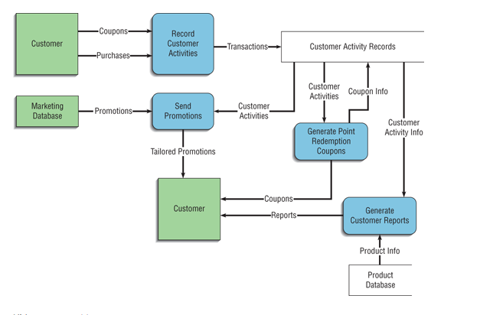**DFD:**

**5. What is Flow chart? Create a flowchart to make addition of two numbers**

* A flowchart is a visual representation of a process or algorithm using different shapes to represent different steps or actions in the process. Each shape typically represents a specific type of operation, decision, or input/output. Arrows indicate the flow of control or data between these elements.

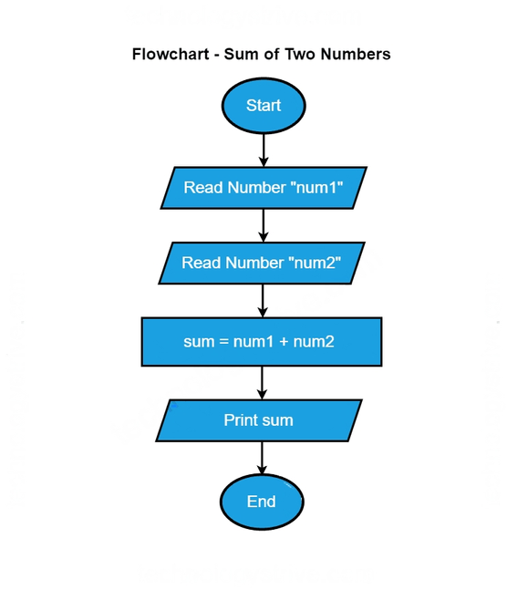

**6. What is Use case Diagram? Create a use-case on bill payment on paytm.**

* A use case diagram is a visual representation of the interactions between users and a system, highlighting the various use cases or scenarios in which users interact with the system to achieve specific goals. Use case diagrams typically involve actors (users or external systems) and use cases (functionalities or services provided by the system).

